

**Golden-Gate Int’l College**

Affiliated to Tribhuvan University

Old Baneswor, Kathmandu

**A**

**Lab Report on**

**Network Programming**

**( CACS355)**

|  |  |
| --- | --- |
| **Submitted by:** | **Submitted to:** |
| Name: Surakshya Lama | Er. Mausam Pokharel |
| Roll no:15 | Submission date: 11th May, 2025 |
| Registration no:6-2-453-15-2021 |  |

# **Chapter 1: Introduction**

## Write a program for Client-Server Approach.

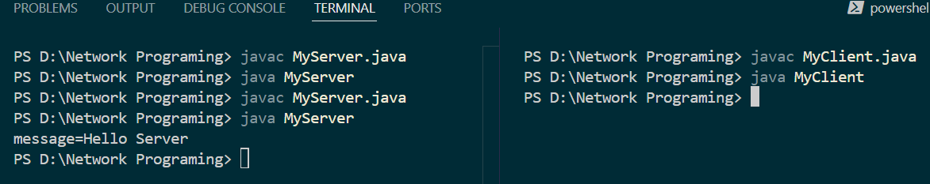

**Chapter 2: InetAddress**

## Write a program to print the address of [www.tufohss.edu.np](http://www.tufohss.edu.np).



## Write a program to print the address of the local machine.

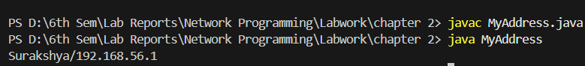

## Write a program that finds the canonical hostname of the given address.



## Write a program to find the IP address and hostname of the local machine.

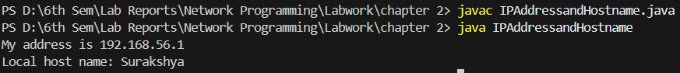

## Write a program to get IPv4 and IPv6 address of the given web address.

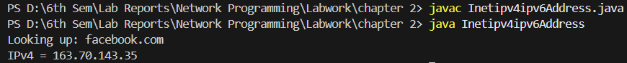

## Write a program for determining whether an Ip address is IPv4 or IPv6.



## Write a program for testing the characteristics of an IP address.

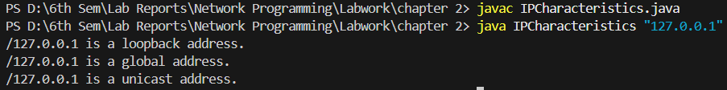

## Write a program that compares the domain name are “[www.ibiblio.org](http://www.ibiblio.org)” and “helios.ibiblio.org” the same?



## Write a program that lists all the network interfaces.

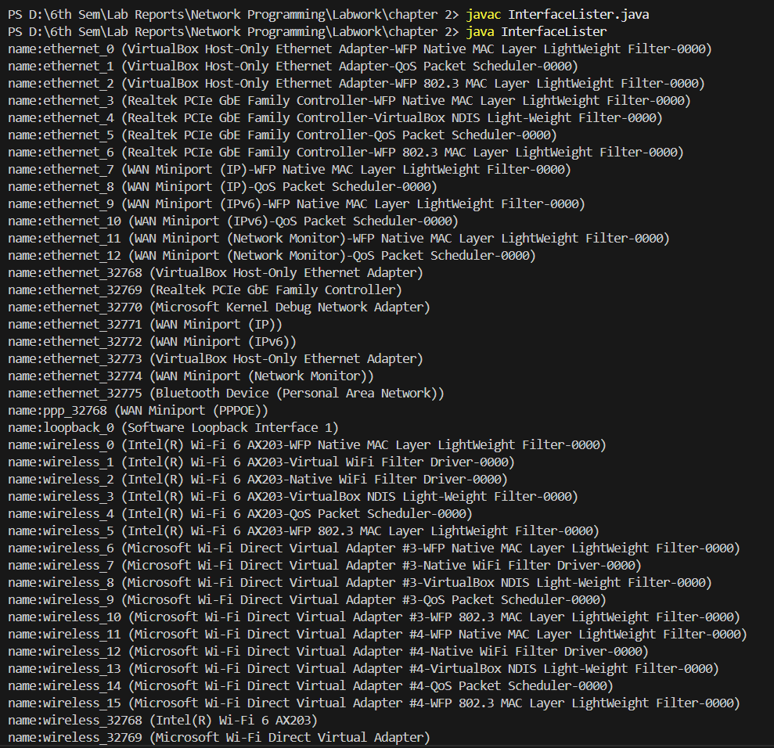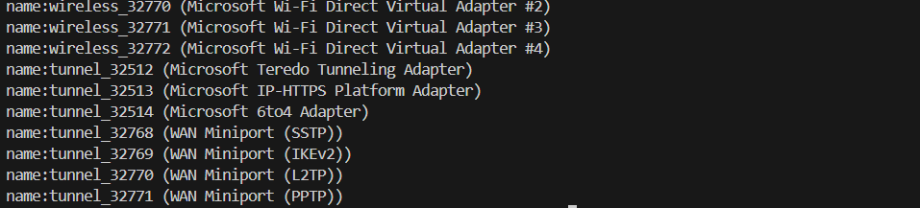

## Write a program that use of network interfaces Getter methods.

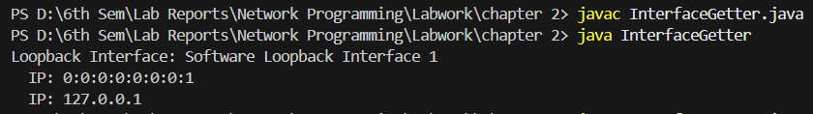

## Write a program to check remote system is reachable or not.



## Write a program that demonstrate the spam check.

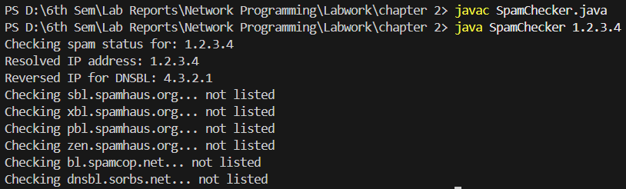

## Write a program to process web server logfiles.

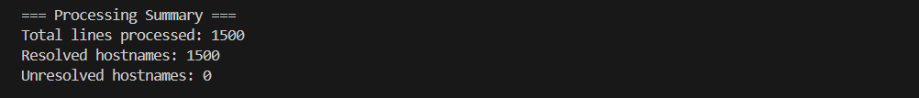

# **Chapter 3: URLs and URIs**

## Write a program that splits the parts of a URL [Splitting URL into pieces information]

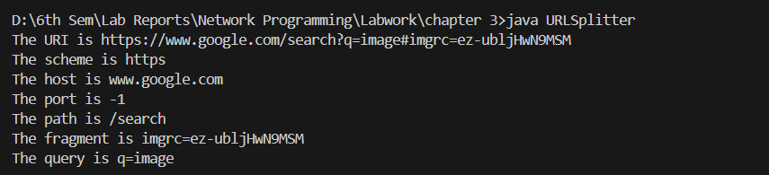

## Write a program that checks the which protocols does a virtual machine support or not?

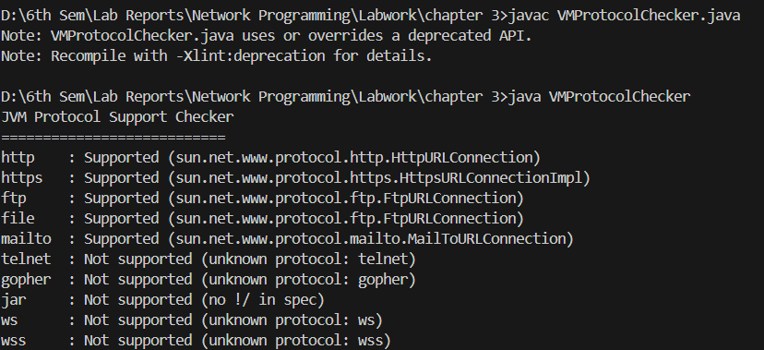

## Write a program to download a web page of a given web address.

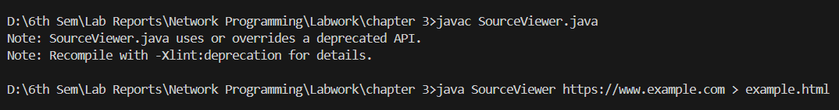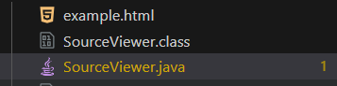

## Write a program for resolving relatives URI.

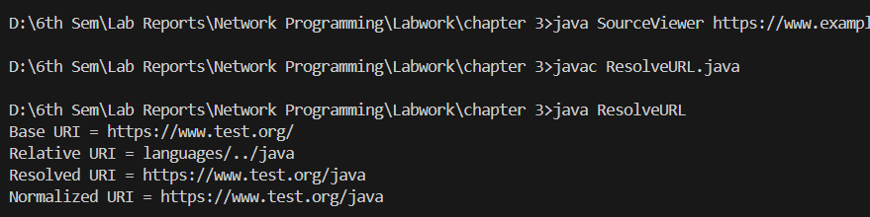

## Write a program to download an object.

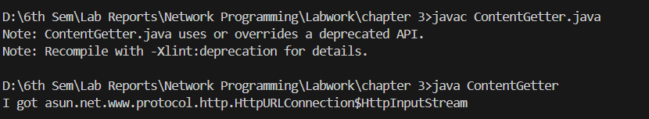

## Write a program to demonstrate the x-www-form-urlencoded strings.

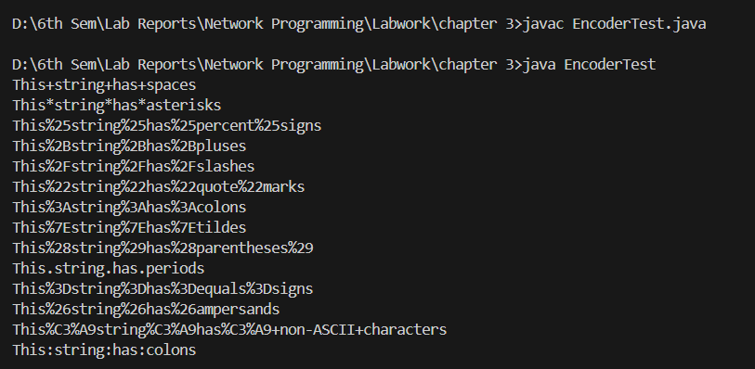

## Write a program that communicating with Server-Side Programs Through GET.

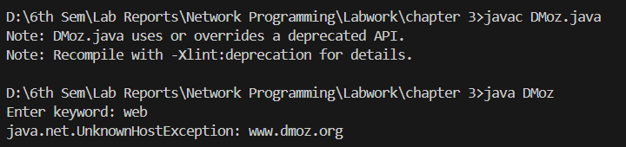

# **Chapter 4: HTTP**

## Write a program that shows a simple CookiePolicy that blocks cookies from .gov domains, but allows others.

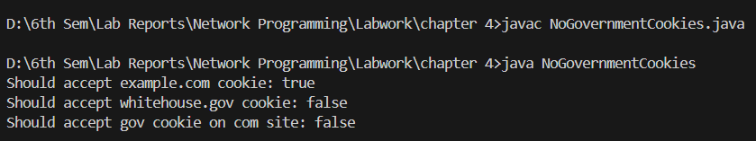

## Program to implement the CookieStore Methods (add, read, delete) cookies.

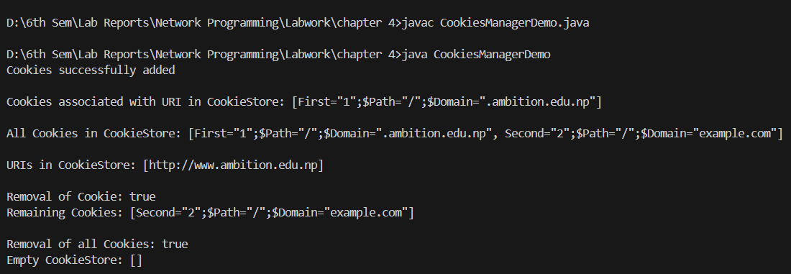

# **Chapter 5: URL Connections**

## Write a program to download a web page using URLConnection.

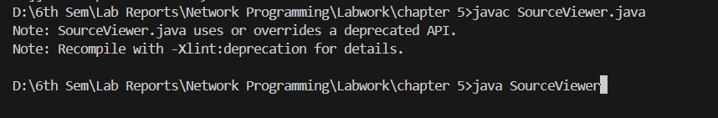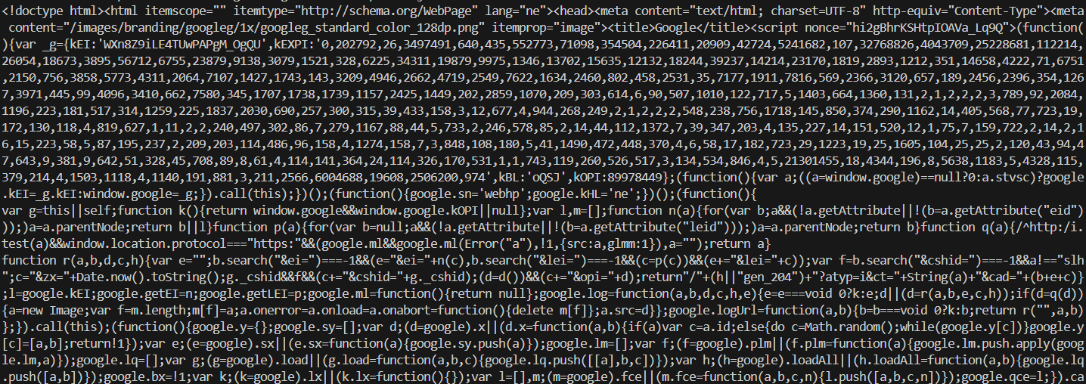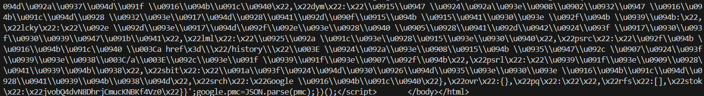

## Write a program to print the entire HTTP Header.

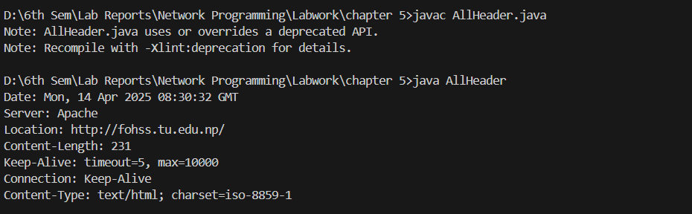

## Write a program to read value of HTTP Header fields.

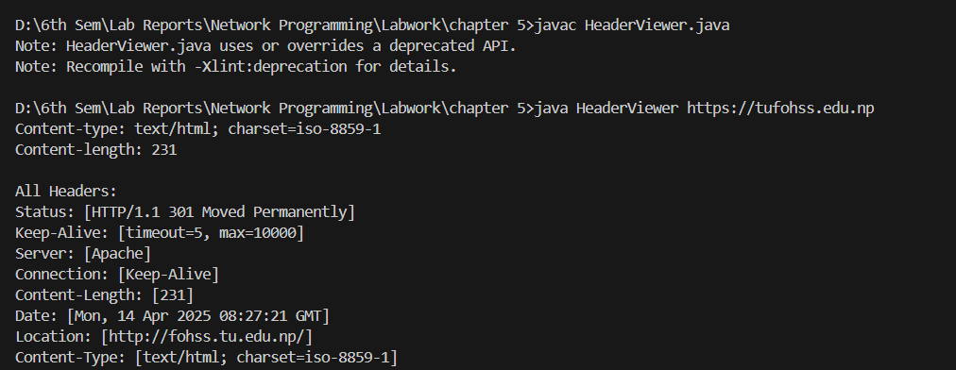

## Write a program for HTTP Request Method.

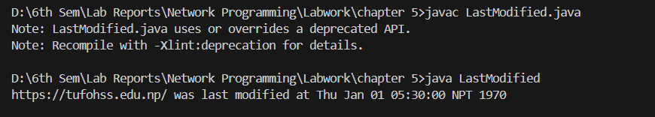

## Write a program to print the URL of a URLConnection to "hafoss.edu.np".

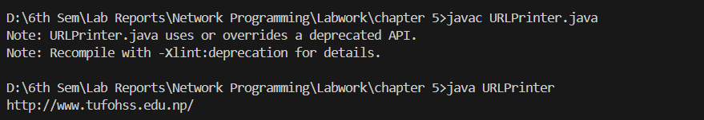

## Write a program to get the time when a URL was last changed.

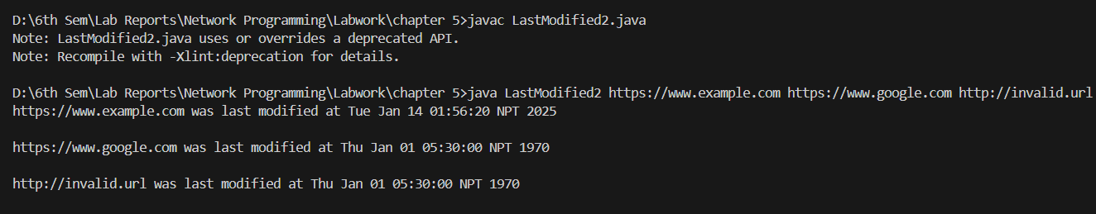

# **Chapter 6: Sockets for Clients**

## Write a program socket to client.

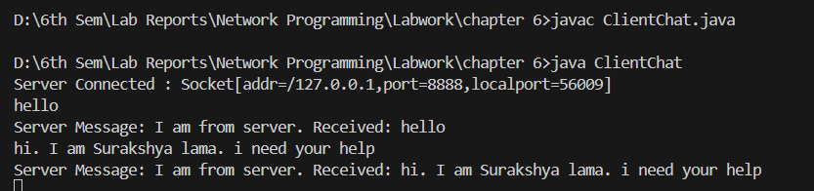

# **Chapter 7: Sockets for Servers**

## Write a program socket for a server.

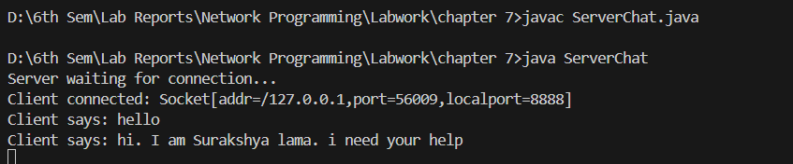

# **Chapter 8: Secure Sockets**

## Write a program for Creating Secure Sockets with tufohss.edu.np.

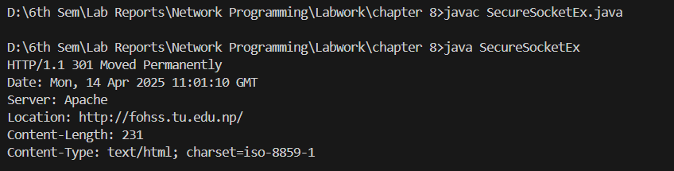

## Write a program for Creating Secure Server Sockets and Client Sockets.

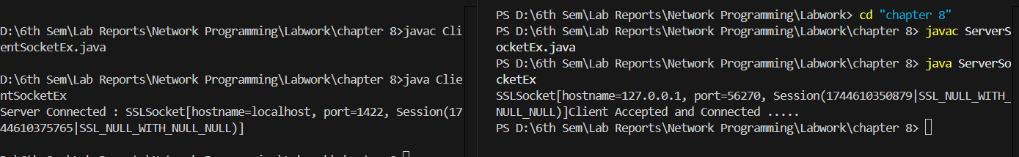

# **Chapter 9: Nonblocking I/O**

## Write program to list all supported socket options for the different types of network channels.

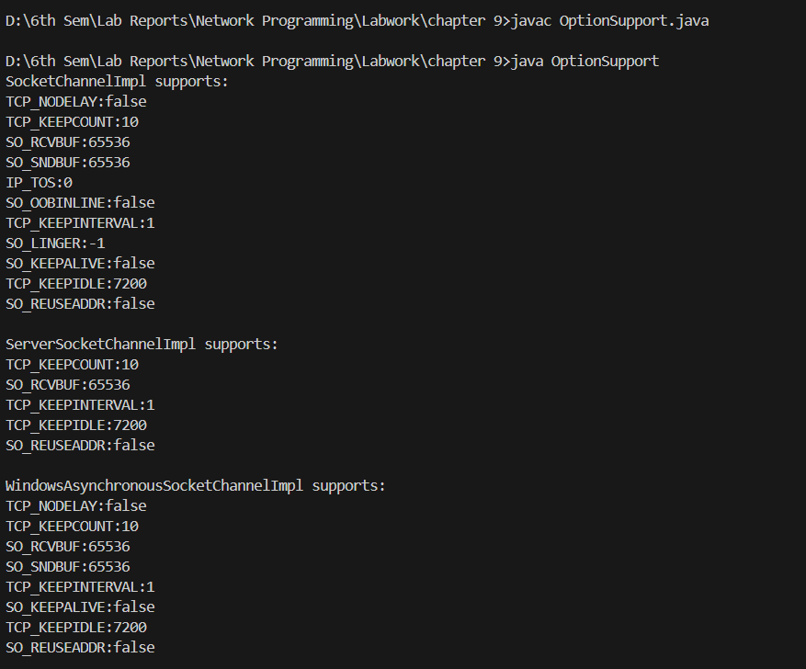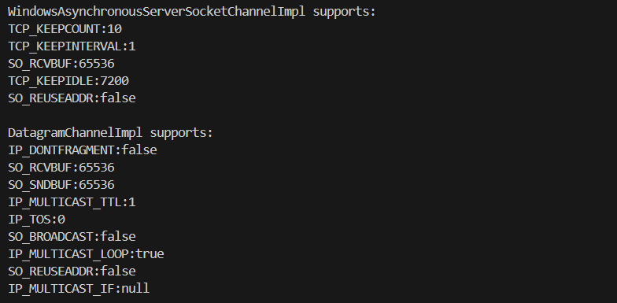

## Write program to implement the concept on Filling and Draining buffer, Duplicating buffer, Slicing buffer, Compact buffer.

FillingDraining.java

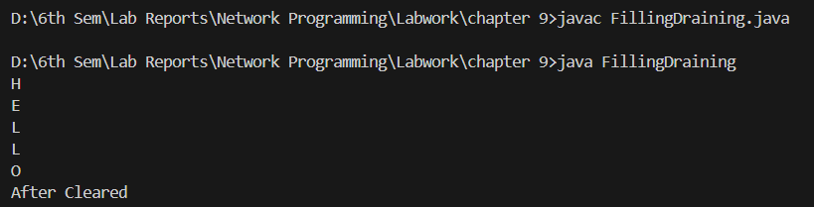

DuplicateBufferEx.java

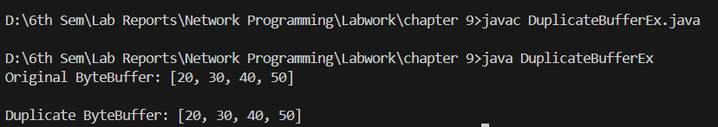

BufferSlicing.java

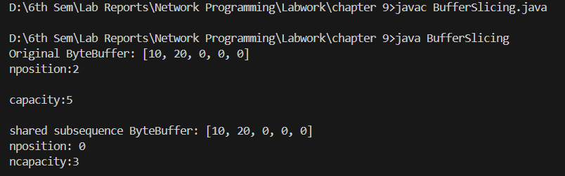

BufferCompactEx.java

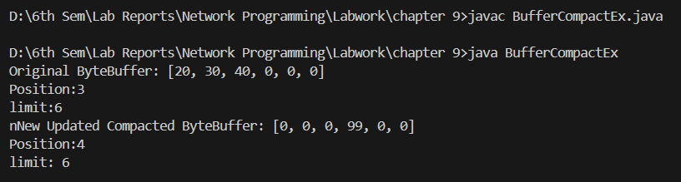

## Write a program to implement the concept on Data Conversion.

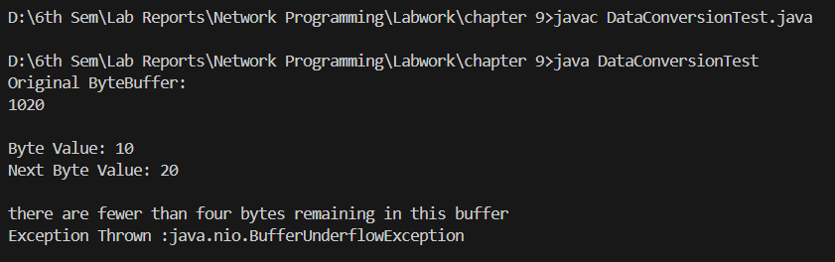

# **Chapter 10: UDP**

## Write a program for UDP Client example.

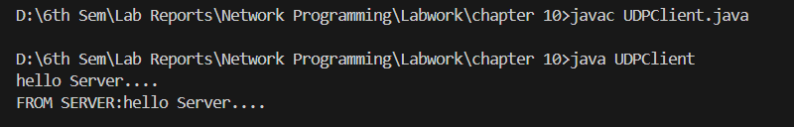

## Write a program for UDP Server example.

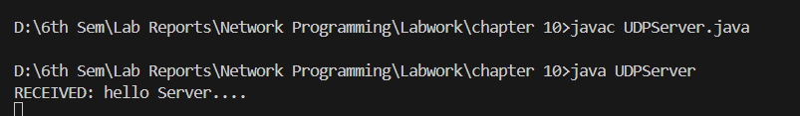

# **Chapter 11: IP Multicasts**

## Program to verify that you are receiving multicast data at a particular host.

MulticastSocketServer.java

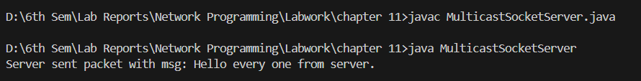

MulticastSocketClient.java

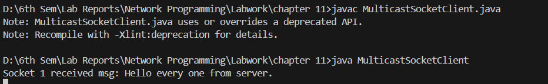

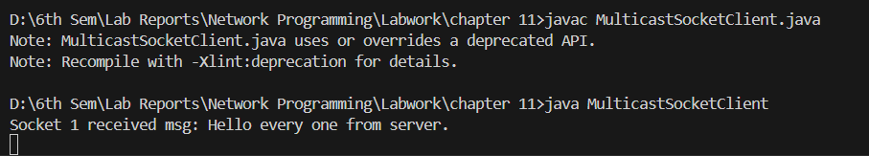

# **Chapter 12: RMI**

## Program to add two numbers using RMI.

Hello.java



ImplExample.java



ServerRMI.java

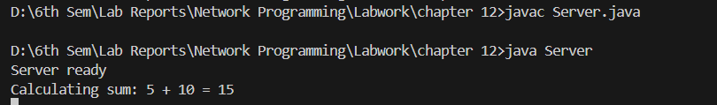

ClientRMI.java

